LAB : 01
Title: Lab Report - Downloading Code::Blocks Software

Introduction:
Code::Blocks is a powerful IDE that offers a user-friendly interface and supports multiple programming languages. It provides features such as code highlighting, code completion, and debugging capabilities, making it a popular choice among programmers. This lab report aims to guide users through the process of downloading and installing Code::Blocks on a Windows system.

Materials and Methods:
- Open your preferred web browser.
- Navigate to the official Code::Blocks website by entering the URL: https://sourceforge.net/projects/codeblocks/ in the address bar and pressing Enter.
- Once on the website's homepage, locate the "Downloads" tab in the top navigation menu and click on it.
- On the Downloads page, you will find different versions of Code::Blocks for various operating systems. Select the appropriate version for your Windows operating system (32-bit or 64-bit). If you are unsure, check your system information by right-clicking "This PC" or "My Computer" on your desktop, selecting "Properties," and looking for the "System Type" field.
- Click on the download link corresponding to your Windows version. This will initiate the download process.
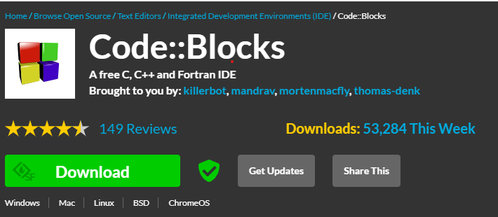
- Once the download is complete, locate the downloaded file in your browser's default download location or the location you specified for downloads.
- Double-click on the downloaded file to start the installation process.
- The installation wizard will guide you through the setup. Click "Next" to proceed.
- Read and accept the license agreement terms and click "Next."
- Choose the installation location for Code::Blocks or keep the default location. Click "Next" to continue.
- Select the desired components to install. By default, all components are selected. It is recommended to keep the default selection unless you have specific requirements. Click "Next."
- Choose the Start Menu folder for Code::Blocks or keep the default setting. Click "Next."
- Select the additional tasks you want to perform. The options include creating a desktop icon and associating supported file types with Code::Blocks. Select the desired options and click "Next."
- Review the installation summary and click "Install" to begin the installation process.
- Wait for the installation to complete. This may take a few minutes.
- Once the installation is finished, you will see a "Completing the Code::Blocks Setup Wizard" screen. Ensure that the "Launch Code::Blocks" checkbox is selected and click "Finish."

Results and Discussion:
By following the aforementioned steps, users can successfully download and install Code::Blocks on their Windows systems. The installation process is straightforward and does not require any advanced technical knowledge.

Conclusion:
Code::Blocks is a versatile IDE widely used for programming in C, C++, and Fortran. This lab report provided a detailed guide for downloading and installing Code::Blocks on a Windows operating system. Following the step-by-step instructions outlined in this report, users can easily obtain and set up Code::Blocks, enabling them to write and debug code efficiently.
Acknowledgments: We would like to thank the developers and contributors of Code::Blocks for providing this powerful open-source IDE to the programming community.
